Atomic Absorption Spectroscopy
By Corey Rowell

Introduction
When atoms are heated the electrons absorb the energy and get ‘excited’, meaning that they jump around electron shells. Light is produced when these electrons return back to their ‘ground state’ and release the absorbed energy (Deb Smith and others, 2014). Different wavelengths of light are all characteristic to certain compounds and elements as each have a unique set of electron configurations. This is all called Emission Spectroscopy and is related to Atomic Absorption Spectroscopy (AAS). Atomic Absorption Spectroscopy is a really useful technique, which has been used to detect the amount of lead content within paints. Lead detection in paints is important as paint used to be made with lead (especially bright yellows for nurseries) and scientist later found out that lead can be poisonous to the body. It can even cause brain damage as it stops oxygen flow to the brain. People nowadays analyse it to make sure that no lead is going into the paints that we use.

Atomic Absorption Spectroscopy
Atomic Absorption Spectroscopy is a technique used to identify the presence and concentration of substances. It relies on the electron transfer between atomic energy levels and measures how much of an element is within the sample (Deb Smith and others, 2014). It does this by shining a light of a certain element into a vaporised sample of the substance being tested. The results are then collected and displayed in the form of numbers on the output display. This can be done to find the amount of lead present in paint or to determine the amount of zinc in tissue samples. The process of using finding the AAS of a substance is done through the use of a machine called an Atomic Absorption Spectrophometer (see fig 1.0)
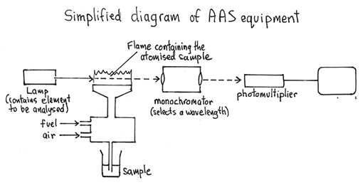

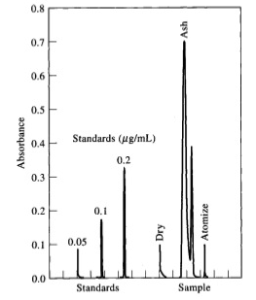
^Fig 1.0
A simplified diagram of an Atomic Absorption Spectrophometer and how it works


The Atomic Absorption Spectrophometer is a machine containing a Hollow Cathode Lamp, a vaporiser, monochromators, photomultiplier and an output display. At the start of the machine it works through using a type of lamp containing the element that is wanted to be located within the sample substance.
<Fig 1.1
Example of results from an atomic absorption Spectrophometer
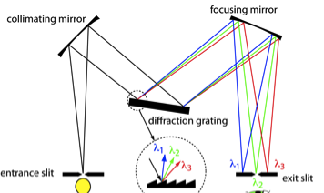
This is called the Hollow Cathode Lamp and it is shone onto a vaporised sample of the substance that is being tested to have traces of the element in the Hollow Cathode Lamp. The element that is being tested will absorb the light from the lamp and the other wavelengths of light continue to penetrate into the monochromator, which selects a wavelength of light and focuses it into the photomultiplier. The monochromator does this by being composed of two slits (entrance and exit for the light) and a dispersion object like a prism or diffraction grating (users.uj.edu.pl, N.D.). The photomultiplier is basically a detector that determines the intensity of the wavelength of light exiting from the monochromator and sends the results to the output display (Dhanlal de Lloyd, 200). The output display then gives results, which are displayed in different ways. These ways depend on the type of read out device used, some of which can be digital meters, recorders, cathode-ray tubes, LCD panels and computer displays (Blogs.maryville, 2015)
<Fig 1.1
Inside of a monochromator

Detecting Lead content in paints



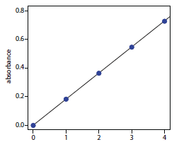
There are two ways in which using AAS to analyse lead content in paints can be done. One of the ways is through the normal use of an atomic absorption Spectrophometer. This is based on the fact that free atoms absorb light at wavelengths characteristic of the element of interest. The ground state for lead atoms is 283.3nm and the amount of light absorbed can be made into a linear fashion, to the concentration of the sample being analysed (who.int/, 2011.). These are called calibration curves (Fig 1.3).



For the lead within the paint to be able to be detected a sample of it needs to be vaporised so that the Hollow Cathode Lamp (containing lead) shines the light through the vaporised particles of paint. These particles containing lead absorb those light waves and the others continue on into the monochromator, which selects a characteristic wavelength of light and displays the results onto the output display. Using this method is generally good, however it is not as accurate as some results can get messed up by the interference of scattered light. This is why another method can by used. This is called Graphite Furnace Atomic Absorption Spectroscopy (GFAAS). GFAAS uses an electrically heated graphite tube to vaporize and atomize the analyte, with temperatures up to 3000ºC (who.int/, 2011). This method is good as it has very low detection limits.
^Fig 1.3
Example of a calibration curve

References

Schiller, Matt. 'Atomic Absorption Spectroscopy (AAS) - Easychem - The Ultimate Resource For HSC Chemistry: Syllabus-Based Dot-Point Study Notes/Summaries, Past Exam Papers, And More'. Easychem.com.au. Web. 22 Mar. 2015.

www.who.int/ brief guide to analytical methods for measuring lead in paint,. N.p., 2011. Web. 22 Mar. 2015.

Davis, Anna et al. Nelson Chemistry Units 1 & 2 For The Australian Curriculum. Print.

Users.uj.edu.pl,. 'Monochromator'. Web. 25 Mar. 2015.

Dhanlal de Lloyd, The Republic of Trinidad and Tobago. 'Atomic Absorption Spectrophotometer Instrument'. Delloyd.50megs.com. N.p., 2000. Web. 25 Mar. 2015.

Blogs.maryville.edu,. 'Processing / Display - Atomic Absorption Spectroscopy Learning Module'. N.p., 2015. Web. 25 Mar. 2015.

CONTENT
Aspect | 0 marks | 2 marks | 4 marks | 6 marks
How the instrument works | Describes a general principle of how machine works but lacks many details | A diagram shows the parts of the instrument and some information is given about what the different parts of the instrument do. | A diagram shows the function of the machine and information is given about the role of different parts of the instrument. Some description of chemical principles underpinning how the machine works using appropriate terminology (e.g. emission and absorption for AAS, elution and retention for GC-MS) | The function of each part is clearly described with details that show a level of research (i.e. not just paraphrased from textbook). Gives elaborate background into the chemical principles relevant to the analytical method (e.g. energy levels and absorption spectra for AAS, chromatographic principles for GC, etc.)
How data from the instrument is used | No explanation of how the output from the machine is used | Describes the type of output generated by the instrument. | Describes how the output of the instrument can be used to analyse, identify or detect substances and includes an appropriate image/table. | Explains how the results are used to analyse, identify or detect substances. Includes example AAS data or GC-MS data and demonstrates how this would be used for the particular application described.
Description of application | Lists the chosen application | Explains the importance of the chosen application. | Explains the importance of the chosen application and describes the chemistry of the substances which need to be analysed.

COMMUNICATING THROUGH ACADEMIC WRITING:
PART 2: ASSIGNMENT
Content = 13 / 16
Communication = 4 / 8
Total = 17 / 24

Overall comments:
You need to make sure that your referencing is following APA format in your bibliography AND in your in-text references. Images also need to have in-text references.

Last section was probably the best – you applied the principles of AAS to lead analysis really well.

Next time add a conclusion

Aspect | 0 marks | 1 mark | 2 marks
References list | - | Most references are correctly formatted using APA. Occasional minor problems. | All references correctly formatted using APA. No errors in referencing details.
In-text citations | - | Some attempt to use in-text citations but some parts are missing citations. | All information that is not common knowledge is attributed using a form of in-text citations.
Sources | - | At least three sources are used including at least one text source.
Conventions for figures and tables | - | Includes at least one figure or table. All figures and tables are labelled, include captions and sources, and are referenced in the main text.
Headings | - | Divides report into logical sections using headings.
Writing | - | High quality presentation of writing with minimal spelling or grammar errors

